**The Phase 3(second requirement changes) test cases and test results**

1. **Requirements testing For the word replacement: all requirements tested here are mentioned with their corresponding number in requirements document, the input passed is also given here along with the actual result(actual result includes the screenshot of the run , test and the output printed by program) and pass/fail status** 
   1. The empty string should print a message saying that the string (text file) is empty.

**Input string passed:**

Empty string

**Status : pass**

**Actual result:**

* 1. The old word (is a given word to be replaced in the text file) shouldn’t be spaces, then print that the space couldn’t be a word.

**Input string passed:**

**Status : pass**

**Actual result:**

* 1. Any old word should be replaced with an empty space as well considering new word to be space.

**Input string passed:**

**Status : pass**

**Actual result:**

**Here the 4th line space space space space is replaced with real space (“ “).**

* 1. Any given word not found in the text file should print an error message saying that the word is not found.

**Input string passed:**

**Old word : hello**

**New word : hellooo**

**Status : pass**

**Actual result:**

* 1. The word could be just a single letter also (‘a’) and when replaced just the ‘a’ Should be replaced all occurrences of it but not when it is a part of another word (eg: “123a” or “ab” Should not be replaced, only ‘a’ should be replaced)

Input string passed:

Old word : a

New word : ab

Status : pass

Actual result:

* 1. The word could be just a period (‘.’) and when replaced just the ‘.’ Should be replaced all occurrences of it but not when it is a part of another word (eg: “123.” Should not be replaced only ‘.’ should be replaced)

Input string passed:

Old word : .

New word : ….

Status : pass

Actual result:

* 1. The word could be just any special character like (eg: ‘$’) and when replaced just the ‘$’ Should be replaced all occurrences of it but not when it is a part of another word (eg: “123$” Should not be replaced only ‘.’ should be replaced)

Input string passed:

Old word : $

New word : $$$$

Status : pass

Actual result:

* 1. The word could be just all special characters (eg: @#$%) and when replaced all occurrences of it should be replaced.

Input string passed:

Old word : #$#

New word : special

Status : pass

Actual result:

* 1. The word could be just one digit number (eg: 1) and when replaced just the ‘1’ and all occurrences of it Should be replaced.

Input string passed:

Old word : 1

New word : one

Status : pass

Actual result:

* 1. The word could be any digit number (eg: 1345) and when replaced all occurrences of it Should be replaced.

Input string passed:

Old word : 12

New word : 1234

Status : pass

Actual result:

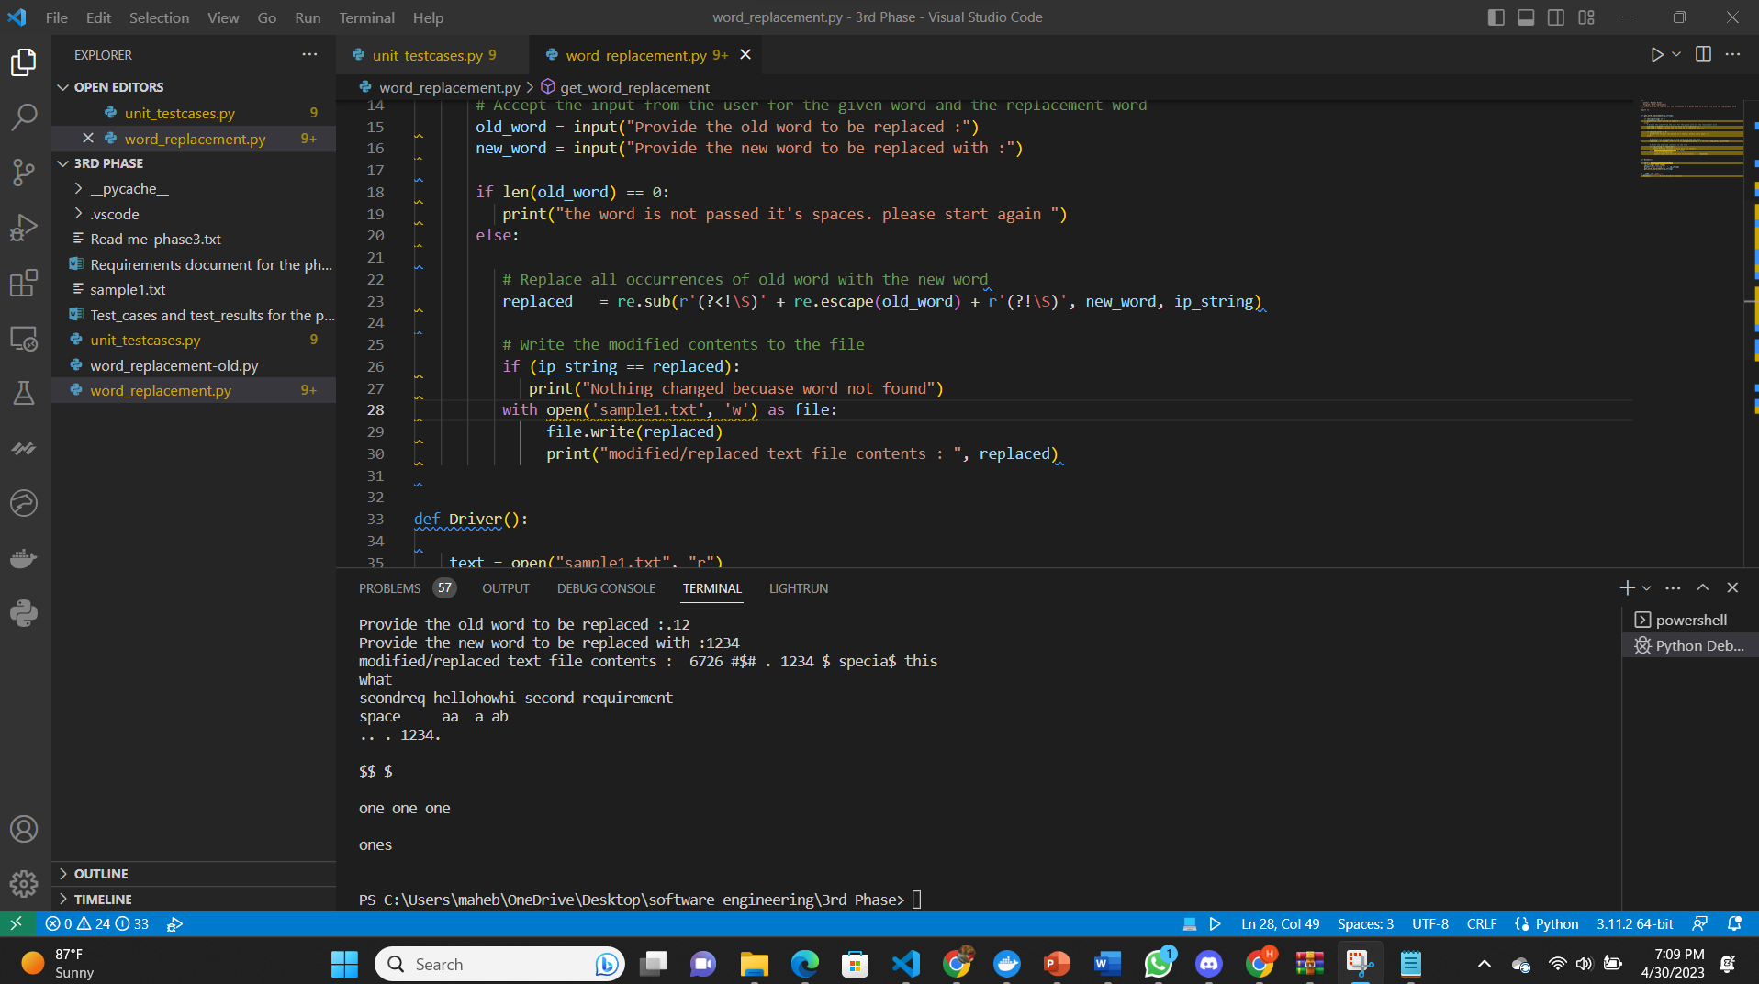

* 1. The word could be an alphanumeric word with special characters and when replaced all occurrences of it Should be replaced.

Input string passed:

Old word : second2%4

New word : alphachange

Status : pass

Actual result:

* 1. When the file has just one single word and the word needs to be replaced should be done.

Input string passed:

Old word : word

New word : singleword

Status : pass

Actual result:

* 1. The string with many occurrences of a word should replace all occurrences of the word with the given word.

Input string passed:

Old word : second2%4

New word : all

Status : pass

Actual result:

* 1. A word of any length (really big words, note: length of size that python permits) should be replaced correctly.

Input string passed:

Old word : seondreqhellohowhisecondrequirement

New word : lengthy

status : pass

Actual result:

* 1. A replacement word could be a string also (eg: “our second requirement” is a word) but the given word to be replaced is always a word that has continuous characters without spaces (eg: “our second’ is not one word while “oursecond12” is considered a word)

Input string passed:

Old word : hellohowareyoudoing

New word : “hello how are you doing”

Status : pass

Actual result:

